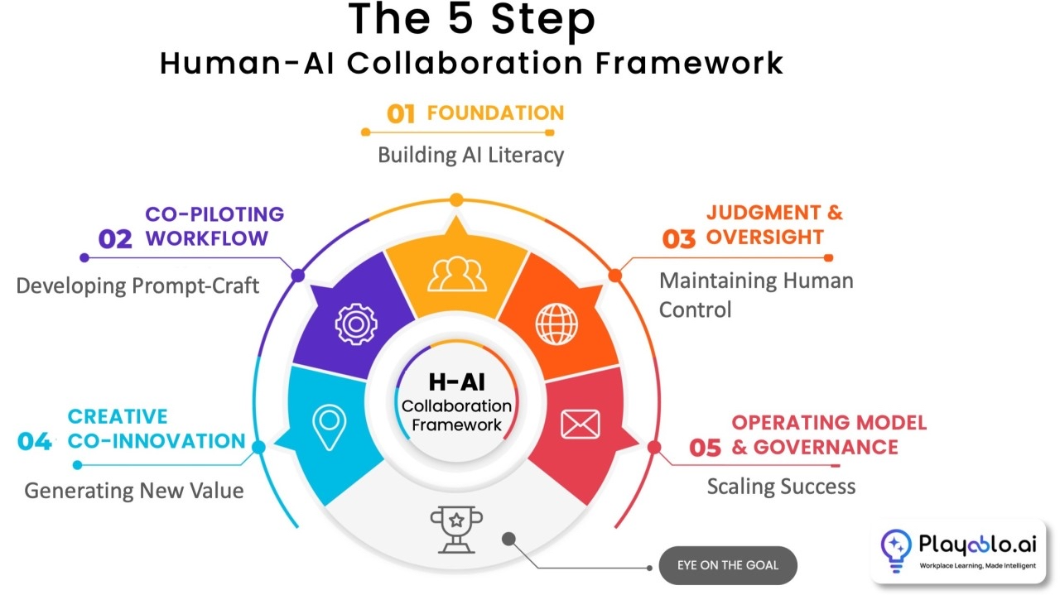
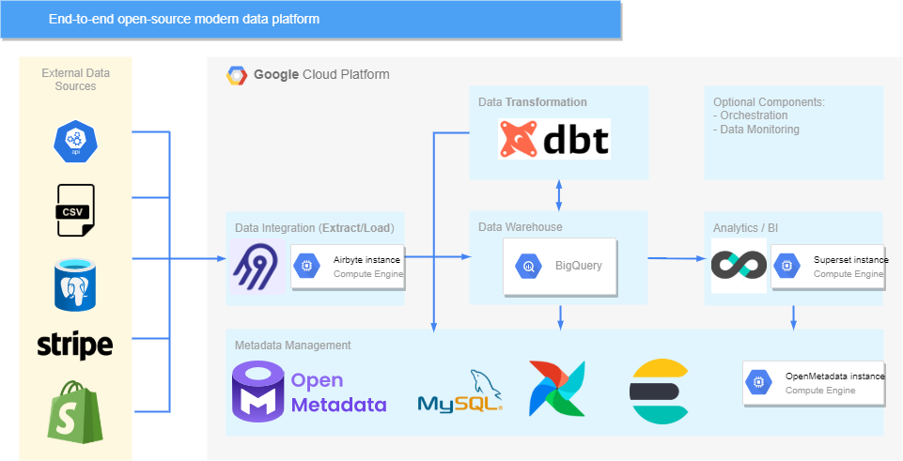

Strategic Development Framework for the Integrated Intelligence Institute (III)

1. Institutional Positioning and Long-Term Trajectory

The Integrated Intelligence Institute (III) is well positioned to occupy a distinctive niche at the intersection of computational social science, applied artificial intelligence, and human–AI collaboration. Its proposed evolution—from a research-oriented nonprofit into a Public Benefit Corporation (PBC) modeled loosely on Posit—is both strategically coherent and normatively defensible. This hybrid trajectory allows III to (1) pursue public-interest research and education in its early stages while (2) gradually building sustainable revenue streams through mission-aligned products, services, and platforms.

The core comparative advantage of III lies in its leadership’s dual expertise in data science infrastructure, pedagogy, and applied software development, coupled with deep ties to universities and student labor markets. This makes III especially suitable for developing research-embedded products—tools and frameworks that originate in academic inquiry but mature into scalable public-benefit technologies.

2. Business Model: Compensation, Incentives, and Governance

2.1 Staff Compensation Model

A phased compensation strategy is advisable:

Phase I (Nonprofit Incubation)
- Core staff: modest but competitive salaries benchmarked against academic research centers and nonprofit think tanks.
- Hybrid compensation: salary + professional capital (authorship, software credits, leadership titles, portfolio visibility).
- Grant supplementation: staff partially supported through externally funded research grants, contracts, and educational programs.

Phase II (Pre-PBC Transition)
- Introduce revenue-sharing mechanisms tied to productized outputs (e.g., licensed software modules, executive training programs).
- Establish IP participation agreements that convert into equity-like interests upon PBC conversion.

Phase III (PBC Conversion)
- Formalize equity-linked compensation, profit-sharing pools, and long-term incentives aligned with public-benefit metrics rather than purely financial KPIs.

2.2 Board of Directors Compensation

To maintain legitimacy and compliance in the nonprofit phase:
- Directors initially serve pro bono or with honoraria, justified by fiduciary and reputational incentives.
- Upon transition to PBC status, board members may receive:
  - Fixed stipends,
  - Equity-like instruments,
  - Performance-based compensation linked to public-benefit benchmarks (e.g., educational reach, open-source adoption, policy impact).

This staged approach balances nonprofit norms with long-term talent retention.

3. Product Direction: Public-Benefit–Oriented Innovation

III should pursue three tightly coupled product verticals, each capable of independent growth yet mutually reinforcing.

3.1 Research-Driven AI Systems (Flagship Direction)

Develop human-in-the-loop AI frameworks for:
- Synthetic data generation for social science and public policy,
- AI-assisted qualitative coding and survey design,
- Simulation environments for governance, crisis response, and decision-making.

Public benefit is delivered through:
- Open research protocols,
- Transparent model documentation,
- Reduced barriers to advanced analytics for under-resourced institutions.

Revenue pathways emerge through:
- Enterprise deployments,
- Government and NGO contracts,
- Advanced feature tiers.

3.2 Educational Infrastructure and Applied Pedagogy

Leverage existing strengths in teaching and curriculum design to produce:
- Modular training platforms (e.g., AI for public policy, data science for social impact),
- Quarto-based open textbooks and toolkits,
- Stackable micro-credentials for students and professionals.

This vertical serves as:
- A talent pipeline for the institute,
- A testing ground for emerging tools,
- A steady source of earned revenue without mission drift.

3.3 Open-Core Software and Research Platforms

Adopt an open-core model:
- Core libraries, data schemas, and research tools remain open source,
- Advanced deployment, scaling, and governance features are commercialized.

This model reinforces public trust while enabling sustainability—an approach well aligned with a future PBC structure.

4. Organizational Design for Operation and Growth

4.1 Internal Structure (Lean but Scalable)

A functional-matrix model is recommended:
- Research & Methods Lab: theory, algorithms, validation.
- Product & Engineering Unit: software development, UX, deployment.
- Education & Outreach Division: curriculum, workshops, partnerships.
- Operations & Governance: grants, compliance, finance, PBC transition planning.

Each unit should be staffed initially with student researchers and interns, supervised by a small number of senior leads.

4.2 Growth Path
- Year 1–2:
  - Establish flagship research products and open-source presence.
  - Secure grants and pilot contracts.
  - Formalize internship and fellowship programs.
- Year 3–4:
  - Spin out mature tools into revenue-generating products.
  - Begin legal and financial preparation for PBC conversion.
  - Expand external partnerships (universities, NGOs, civic tech organizations).
- Year 5+:
  - Convert to PBC while retaining a nonprofit research arm if advantageous.
  - Scale products internationally with explicit public-benefit reporting.

5. Recruitment and Integration of Student Interns

Student interns should be treated as junior researchers and developers, not auxiliary labor.

Recommended mechanisms:
- Competitive, paid internships tied to academic credit or fellowships,
- Clear project ownership with publication and software attribution,
- Tiered progression: intern → fellow → staff researcher.

This model strengthens III’s mission by:
- Expanding research capacity,
- Democratizing access to advanced AI work,
- Building a loyal talent ecosystem aligned with public-interest values.

6. Balanced Assessment: Opportunities and Risks

Opportunities
- Strong alignment with current funding priorities (AI, ethics, public governance),
- Differentiation from purely commercial AI firms,
- High legitimacy among academic and civic stakeholders.

Risks
- Tension between open research and monetization,
- Governance complexity during nonprofit–PBC transition,
- Dependence on grant funding in early stages.

Mitigation requires disciplined product scoping, transparent governance, and early legal planning.

Conclusion

The Integrated Intelligence Institute has the structural ingredients to become a model organization for public-interest AI: intellectually credible, pedagogically innovative, and economically sustainable. By deliberately sequencing its business model, product strategy, and organizational growth, III can replicate—and in some respects improve upon—the nonprofit-to-PBC pathway exemplified by Posit, while remaining firmly anchored to its mission of integrating human and artificial intelligence for societal benefit.

